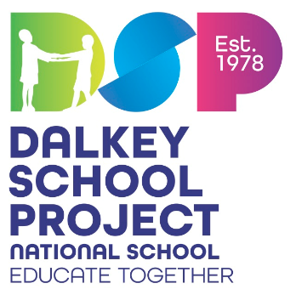

Dear Parents/Guardians

The Primary Schoolbooks Scheme grant will cover the cost of workbooks, copybooks and some related classroom resources. The books and most resources have already been ordered and are ready to go for next year. We have received our IT grant for purchase of equipment this year so thankfully payments by parents to the school to fund additional resources and supports is less this year.

|  |  |
| --- | --- |
| Payment to the school | |
| I.T. Maintenance/ Digital Education | €30 |
| New Equipment e.g. Aistear etc. | €10 |
| The annual subscription fee of €3 to Dalkey School Project Executive and of €15 to Educate Together | €18 |
| **Total** | **€58** |

*Please pay online through the Aladdin Connect epayments option. If you have any difficulties with the cost please speak to the Principal in confidence. Requests will be strictly confidential.*

It would be of great benefit to your child if you have the opportunity in the summer to continue the work begun in Junior Infants. Here are some ideas of ways to do this:

* Revise sounds in Sound book.
* Revise tricky words. (Stick them on cards on the fridge or play snap or look for these words in stories or in the newspaper)
* Visit the library. We are following the Oxford Reading Tree programme so please avoid books from this series but your librarian should be able to help you with other suitable reading material from another series.
* Fine motor skills practice (ie cutting, playdough, clay, beadwork etc).
* Use the Oxford Reading Tree website for additional activities.
* Practice tying laces, zipping up jackets, putting straws into drink cartons

We hope you have a wonderful summer. See you in September!

The Senior Infant Team