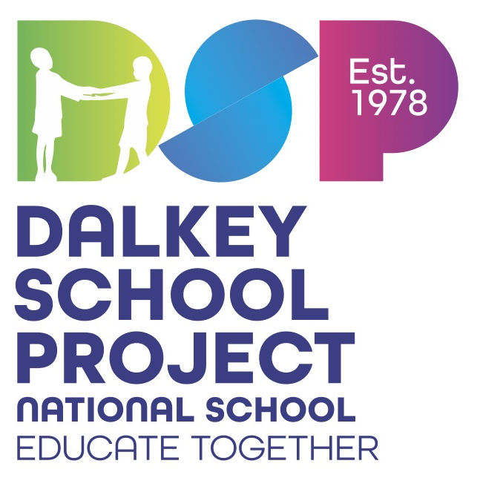

Dear Parents/Guardians

The Primary Schoolbooks Scheme grant will cover the cost of workbooks, copybooks and some related classroom resources. The books and most resources have already been ordered and are ready to go for next year. We have received our IT grant for purchase of equipment this year so thankfully payments by parents to the school to fund additional resources and supports is less this year.

|  |  |
| --- | --- |
| Payment to the school | |
| I.T. Maintenance/ Digital Education | €30 |
| The annual subscription fee of €3 to Dalkey School Project Executive and of €15 to Educate Together | €18 |
| **Total** | **€48** |

*Please pay online through the Aladdin Connect epayments option. If you have any difficulties with the cost please speak to the Principal in confidence. Requests will be strictly confidential.*

|  |
| --- |
| **Additional Items Required** |
| Set of whiteboard markers & 1 Mini Whiteboard |
| A set of colouring pencils/ A long ruler/2 x Glue stick (large) |
| 2 x Blue handwriting pens - Rollerball style ink pen (e.g. Pilot Frixion Pen),  *No ballpoint  Biro pens or erasable pens please*  2 x green biros, 2 x red biros (no erasable pens) |
| A basket to hold books (measuring no more than 28 x 35cm) |
| 1 X A4 Zip Mesh Wallet & 1 X A3 Zip Mesh Wallet  1 x A4 plastic document wallet |

As a way of reducing waste and showing care for our environment, we strongly urge you and your child to reuse any equipment you can for next year**. Reduce, Reuse, Recycle!**

We hope you have a wonderful summer.

See you in September!

4th Class Team